Department of CSE-IOT

Vision of the Department
To be a preferred hub for nurturing computer engineering aspirants through innovative, ethical, value-based technical education, impactful research, and industry collaboration, to become successful professionals contributing for the betterment of society.

Mission of the Department
To nurture computer engineering professionals by offering: Dynamic learning environment that encourages problem-solving using emerging technology, · National Education Policy aligned evidence-based technical education, fostering innovation, research, and industry–institute
collaboration, Holistic, ethical and sustainable development for lifelong success.

Session 2025-2026(EVEN)
Mission: Means to achieve Vision
Vision: Dream of where you want.
Program Educational Objectives of the program (PEO): (broad statements that describe the professional and career accomplishments)
PEO1 | Preparation | P: Preparation | Pep-CL abbreviation  pronounce as Pep-si-lL easy to recall
PEO2 | Core Competence | E: Environment (Learning Environment)
PEO3 | Breadth | P: Professionalism
PEO4 | Professionalism | C: Core Competence
PEO5 | Learning Environment | L: Breadth (Learning in diverse areas)

Program Outcomes (PO): (statements that describe what a student should be able to do and know by the end of a program)

Keywords of POs:
Engineering knowledge, Problem analysis, Design/development of solutions, Conduct Investigations of Complex Problems, Engineering Tool Usage, The Engineer and The World, Ethics, Individual and Collaborative Team work, Communication, Project Management and Finance, Life-Long Learning
PSO Keywords: Cutting edge technologies, Research
“I am an engineer, and I know how to apply engineering knowledge to investigate, analyse and design solutions to complex problems using tools for entire world following all ethics in a collaborative way with proper management skills throughout my life.” to contribute to the development of cutting-edge technologies and Research.

Integrity: I will adhere to the Laboratory Code of Conduct and ethics in its entirety.
Anushka yede

Name and Signature of Student and Date
(Signature and Date in Handwritten)

Department of CSE-IOT

Vision of the Department
To be a preferred hub for nurturing computer engineering aspirants through innovative, ethical, value-based technical education, impactful research, and industry collaboration, to become successful professionals contributing for the betterment of society.

Mission of the Department
To nurture computer engineering professionals by offering: Dynamic learning environment that encourages problem-solving using emerging technology, · National Education Policy aligned evidence-based technical education, fostering innovation, research, and industry–institute
collaboration, Holistic, ethical and sustainable development for lifelong success.

Session | 2024-25 (EVEN) | Course Name | Mobile and Web Application for IOT Lab
Semester | 6 | Course Code | 23IOT1624
Roll No | 01 | Name of Student | Anushka Yede

Practical Number | Practical no 2
Course Outcome | - Understand and apply basic Kotlin programming constructs including variables, control structures, functions, null safety, and object-oriented concepts for Android app development.  - Design and develop responsive user interfaces using XML layout files, ViewGroups, and widgets in Android Studio, adhering to Material Design principles.  - Implement event handling and application logic using Kotlin to capture user input, manage app state, navigate between screens, and interact with Android system components like Toasts and Dialogs  - Integrate learned concepts to develop a mini Android application that demonstrates use of ViewModel, multi-screen navigation, and proper UI/UX design for real-world problem- solving
Aim | Objective: Understand Kotlin functions, null safety, and OOP concepts.
Problem Definition | Functions with default/named arguments, nullable types, null safety operators, classes, inheritance, constructors, data classes, enums
Theory  (100 words) | Kotlin supports clean and safe programming using functions, null safety, and object-oriented concepts. Functions can have default values and be called using named arguments, improving readability. Kotlin’s null safety avoids runtime crashes by distinguishing nullable and non-nullable types and using operators like ?., ?:, and  !!. Object-oriented programming in Kotlin includes classes, constructors, inheritance, data classes, and enums. Classes define objects, constructors initialize data, inheritance allows code reuse, data classes automatically handle common methods, and enums represent fixed constant values. These features make Kotlin concise, safe, and ideal for Android development.
Procedure and Execution | Step for Implementation:  Create a Kotlin function with default parameters to reduce

(100 Words) | repetitive code.  Call the function using named arguments for better readability. Declare nullable variables using the ? symbol.  Access nullable variables safely using ?., ?:, and !! operators. Define a base class with common properties and methods.  Create a child class using inheritance to reuse functionality. Use constructors to initialize class properties.  Implement a data class to store and manage structured data easily.  Define an enum class to represent fixed constant values. Compile and execute the program in Kotlin Playground or  Android Studio.
Code:
1) Kotlin playground
// 1. Function with default & named arguments fun displayStudentInfo(
name: String, age: Int,
department: String = "Computer Science"
) {
println("Name: $name") println("Age: $age") println("Department: $department")
}
// 6. Enum Class
enum class StudentStatus { ACTIVE,
INACTIVE, GRADUATED
}
// 3. Base Class open class Person(
val name: String, val age: Int
) {
open fun getRole(): String { return "Person"
}
}
// 3. Derived Class + 4. Constructors class Student : Person {

val rollNo: Int
val department: String
val email: String? // 2. Nullable property
// Primary Constructor constructor(
name: String, age: Int, rollNo: Int,
department: String, email: String?
) : super(name, age) { this.rollNo = rollNo this.department = department this.email = email
}
// Secondary Constructor (default department) constructor(
name: String, age: Int, rollNo: Int, email: String?
) : this(name, age, rollNo, "Computer Science", email)
override fun getRole(): String { return "Student"
}
}
// 5. Data Class
data class StudentRecord( val rollNo: Int,
val name: String, val age: Int,
val department: String
)
fun main() {
// Calling function using named arguments displayStudentInfo(
name = "Vedant", age = 20
)

println(" ")
// Creating Student object val student = Student(
name = "Vedant", age = 20,
rollNo = 101, email = null
)
// 2. Null Safety
val emailLength = student.email?.length println("Email Length: $emailLength")
val emailMessage = student.email ?: "Email not provided"
println("Email Status: $emailMessage")
// 7. Business Logic
val status = if (student.age >= 18)
StudentStatus.ACTIVE else
StudentStatus.INACTIVE
// Student Record
val record = StudentRecord( student.rollNo, student.name, student.age, student.department
)
println(" ")
println("Role: ${student.getRole()}") println("Status: $status") println("Student Record: $record")
}

Department of CSE-IOT

Vision of the Department
To be a preferred hub for nurturing computer engineering aspirants through innovative, ethical, value-based technical education, impactful research, and industry collaboration, to become successful professionals contributing for the betterment of society.

Mission of the Department
To nurture computer engineering professionals by offering: Dynamic learning environment that encourages problem-solving using emerging technology, · National Education Policy aligned evidence-based technical education, fostering innovation, research, and industry–institute
collaboration, Holistic, ethical and sustainable development for lifelong success.

Output:
Code 1
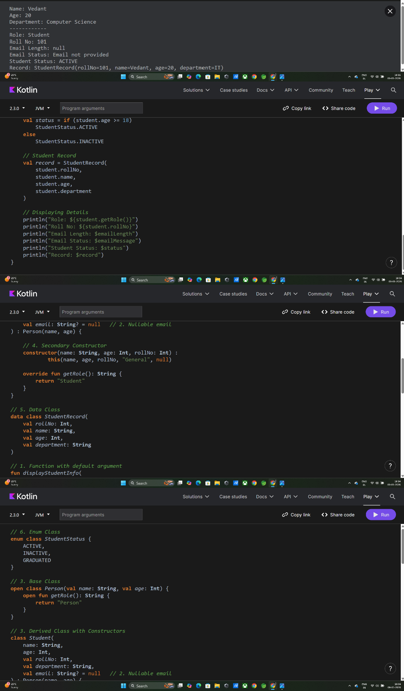

Code 2
2) Andriod Studio code

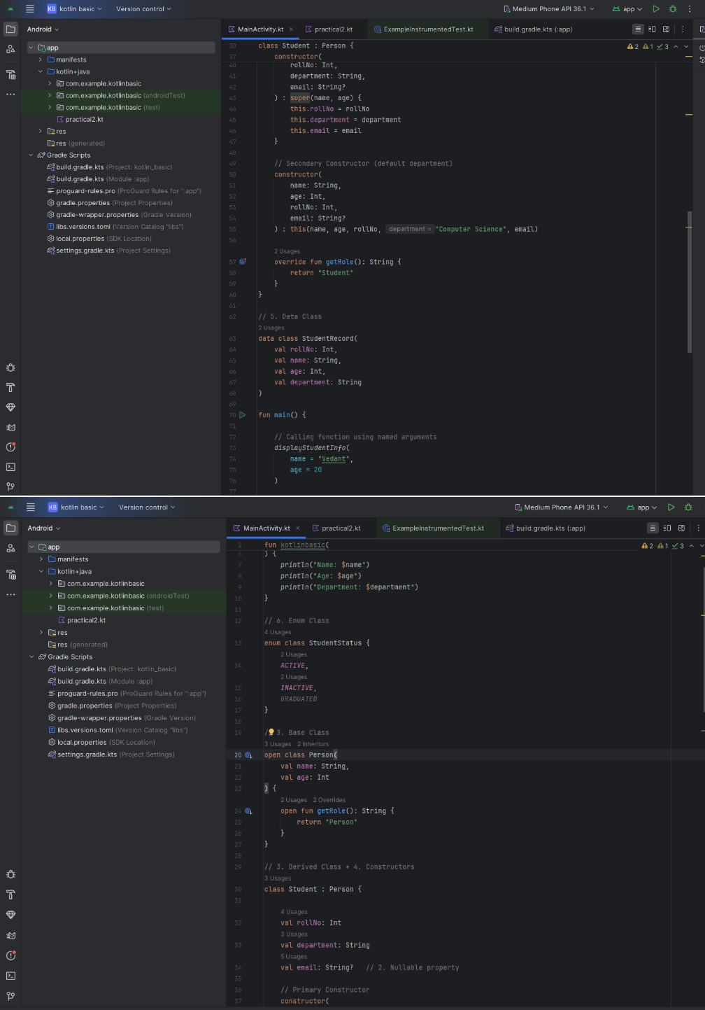

 | 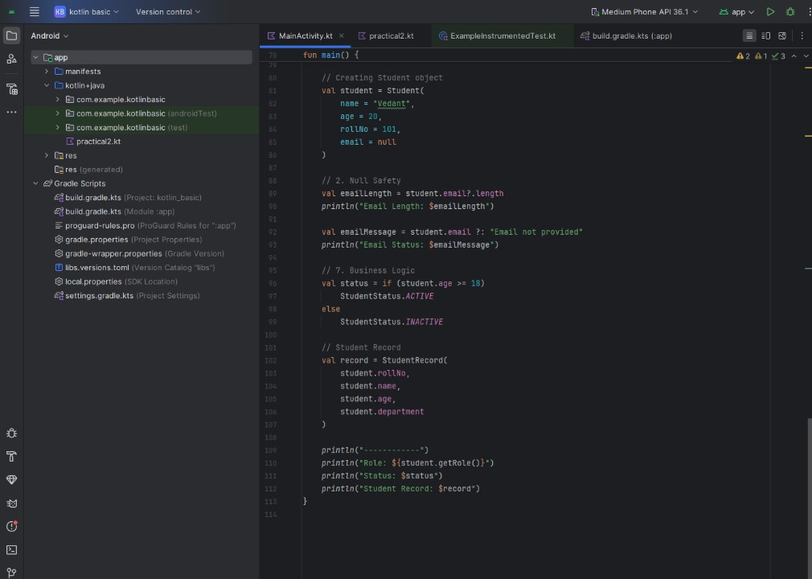
Output Analysis | The output displays correctly formatted student or object details using functions with named arguments. Nullable values are handled safely without crashes. Inherited properties and methods work as expected. Data classes print readable object information  automatically. Enum values restrict invalid inputs.
Link of student Github profile where lab assignment has  been uploaded | https://github.com/23071016/MWIOT-.git
Conclusion | Kotlin simplifies programming by combining safety, clarity, and object-oriented principles. Its null safety prevents common errors, while OOP features promote reusable and maintainable code. These  concepts are essential for building reliable Android applications.
Plag Report (Similarity index < 12%) | 
Date | 15/1/26

